API Document for prescription information enrollment system
This API will store the information of patient and their Insurance details
URL for showing the Interface : https://staging.erxit.com/forms/xeljanz/forms/xelsource_enroll.html

Database Structure
Table Name: 1 patient
2 patient_insurance
3 prescriber_details
4 Patient_Diagnosis
5 prec_coverage
6 diag_master
7 diag_medicine
8 state_master
9 city_master
10 pincode_master
1 Patient Table Structure : This table contains the basic demographics data of patient.
Slno | Field | Datatype | Description
1 | first_name | Varchar (55) | Stores first name
2 | middle_name | Varchar(55) | Stores first name
3 | last_name | Varchar(55) | Stores first name
4 | Dob | Date | Stores date of birth in yyyy/mm/dd format
5 | gender | Varchar(1) | M/F/or O
6 | Resident | Varchar(255)
7 | Address | Varchar(255) | Address of the patient
8 | City | Number | City code from city master
9 | state | Number | State code from state master
10 | Zip | Number | Zip code form zip master
11 | Pr_phone | Varchar(15) | Phone number
12 | Type_pr_ph | Varchar(1) | H/W/M
13 | Alt_ph | Varchar(15) | Alternate Phone number
14 | Type_alt_ph | Varchar(1) | H/W/M
15 | email | Varchar(255) | Email address of patient
16 | Best_rch_time | Varchar(1) | M/A/E
17 | Prfd_lang | Varchar(35) | Preffered Language
18 | caregvr _name | Varchar(1) | Caregiver name
19 | caregvr _phone | Varchar(15) | Phone number caregiver
20 | caregvr_ph_type | Varchar(1) | H/W/M
21 | caregvr _email | Varchar(35) | Email of caregiver
24 | status | Varchar(1) | 1 or 0. 1 for Active ; o for Inactive
25 | Preff_pharm | Varchar(255) | Name of pharmacy
26 | Is_self_pharm | Varchar(1) | 1/0
27 | Pharm_add | Varchar(255) | Address of pharmacy
28 | Pharm_city | Varchar(10) | City code from city master
29 | Pharm_state | Varchar(10) | State code from state master
30 | Pharm_zip | Varchar(10) | zip code from zip master
31 | res_certify | Varchar(1) | 1/0
32 | Cell_num_consent | Varchar(1) | 1/0
33 | Cell_number | Varchar(15) | Cell number for texting
34 | Patient_name | Varchar(255) | Name of patient
35 | date_of_certify | date | Date of certify
36 | Sign | Varchar(255) | Signature address
37 | relationship | Varchar(50) | Relationship
22 | Posted_date | Varchar(1) | Date of record entry
23 | Ip_address | Varchar(20) | Strore ip address of client system

Patient_Insurance: This table contains information about patient primary insurance , Secondary Insurance.
Slno | Field | Datatype | Description
1 | Pat_id | Varchar (55) | Patient id, whose the insurance is
2 | type_of_insurance | Varchar(1) | H/W/M
3 | Pres_cover | Varchar (1) | 1 if not have pres cov. And 0 if have
4 | Sec_pres_cover | Varchar (1) | 1 /0
5 | insurance_name | Varchar(55) | Insurance name
6 | phone | Varchar(55) | Phone number
7 | Policy_id | Varchar(55) | Policy Id
8 | grp | Varchar(1) | M/F/or O
9 | policy_hold_name | Varchar(255) | name
10 | Address | Varchar(255) | Address of the patient
11 | Rel_to_pat | Number | City code from city master
12 | Pol_hld_dob | Number | State code from state master
13 | bin | Number | Zip code form zip master
14 | pcn | Varchar(15)
15 | alt_phone | Varchar(15) | Alternate Phone number

prescriber_details : Contains information about prescriber
Slno | Field | Datatype | Description
1 | Pat_id | Varchar (55) | Patient id, whose the insurance is
2 | Pres_fname | Varchar(1) | H/W/M
3 | Pres_lname | Varchar (1) | 1 if not have pres cov. And 0 if have
4 | speciality | Varchar (1) | 1 /0
5 | Grp_tax_id | Varchar(55) | Insurance name
6 | State_lic | Varchar(55) | Phone number
7 | Practice_name | Varchar(55) | Policy Id
8 | Office_cont | Varchar(1) | M/F/or O
9 | address | Varchar(255) | name
10 | city | Varchar(255) | Address of the patient
11 | state | Number | City code from city master
12 | zip | Number | State code from state master
13 | email | Number | Zip code form zip master
14 | phone | Varchar(15)
15 | fax | Varchar(15) | Alternate Phone number
16 | sign | Varchar(15) | Signature path

Patient_Diagnosis : This table contains the diagnosis of patient
Slno | Field | Datatype | Description
1 | Pat_id | Varchar (55) | Patient id
2 | ra | Varchar(1) | Rheumatoid Arthritis Value
3 | psa | Varchar (1) | Psoriatic Arthritis
4 | uc | Varchar (1) | Ulcerative Colitis
5 | Pcjia | Varchar(55) | Polyarticular Course Juvenile Idiopathic Arthritis (pcJIA)
6 | Posted_on | date | Date of entry

prec_coverage : contains medicine coverage data of each patients
Slno | Field | Datatype | Description
1 | Pat_id | Varchar (55) | Patient id
2 | Diag_id | Varchar(255) | Rheumatoid ArthritisValue ; in json format
3 | Medicine_id | Varchar (255) | Psoriatic Arthritis; in json format
4 | Posted_on | date | Date of entry

diag_master : This table contains the master of all diagnosis
Slno | Field | Datatype | Description
1 | Diag_id | autonumber | Patient id
2 | Diag_name | Varchar(1) | Name of diagnosis
3 | status | Varchar(55) | 1/0

diag_medicine : This table will contains the medicine against each diagnosis
Slno | Field | Datatype | Description
1 | diag_id | Varchar (55) | Patient id
2 | med_name | Varchar(1) | Medicine name
3 | status | Varchar(1) | 1/0

state_master : This table will contains the medicine against each diagnosis
Slno | Field | Datatype | Description
1 | state_id | Varchar (55) | Unique id of state
2 | state_name | Varchar(1) | State name
3 | status | Varchar(1) | 1/0

city_master : This table will contains the medicine against each diagnosis
Slno | Field | Datatype | Description
1 | city_id | Autonumber | Unique id of city
2 | state_id | Varchar(1) | State id
3 | name | Varchar(55) | City Name
4 | status | Varchar(1) | 1/0

pincode_master : This table will contains the medicine against each diagnosis
Slno | Field | Datatype | Description
1 | id | autonumber | Unique id of pincode
2 | city_id | Varchar (55) | City id
3 | state_id | Varchar(10) | State Id
4 | zip_number | Varchar(10) | Zip Number
5 | status | Varchar(1) | 1/0

This form structure is used by user to send their information to server.
Note: Proper field validation.

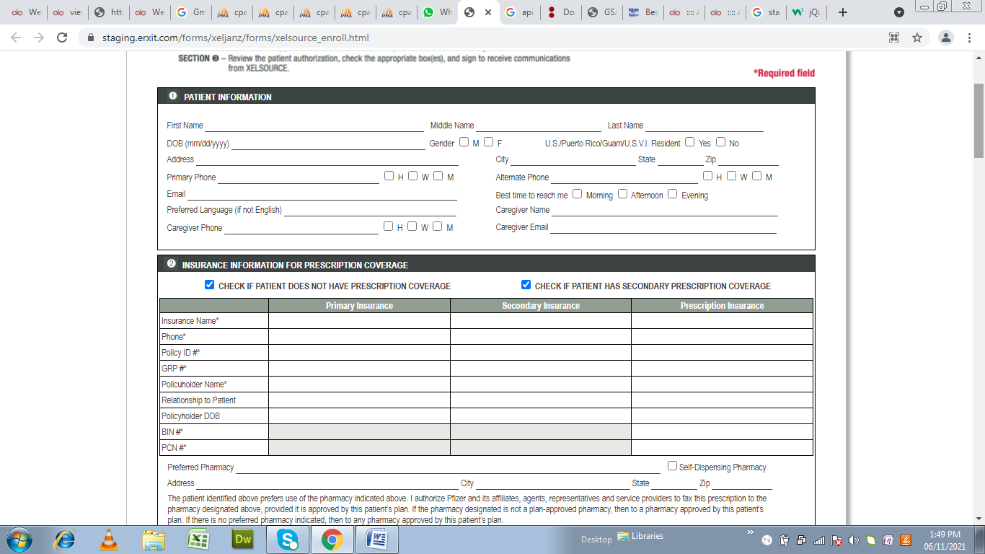
Ajax post url : https://staging.erxit.com/forms/xeljanz/forms/register

Method : POST
Type : JSON

